

Handbook
Soft skills for
engineering students
Vassilia Kazamia, PhD Ivana Jurković, MA Tatjana Badrov, MSc





Vassilia Kazamia, PhD Ivana Jurković, MA Tatjana Badrov, MSc

SOFT SKILLS FOR ENGINEERING STUDENTS
HANDBOOK

Reviewers:
Zoran Vrhovski, PhD, College Prof.
Tomislav Adamović, s. lect.
Proofreading:
Ivana Jurković, MA Vassilia Kazamia, PhD
Technical support:
Krunoslav Husak, lect.
Design:
Ceky GSM j.d.o.o.

© This publication has been released as an Open Educational Resource (OER) under an open license that permits no-cost access, use, adaptation and redistribution by others with no or limited restrictions. Attribution is required.









CONTENTS

Note 1
Expected outcomes 2
Deﬁning presentation 3
Preparation of a presentation 5
Designing and creating 8
presentation
Practising a presentation 14
Performance 17
Appendices 21
Tips on delivery 27
References 32


This corpus comprises:
NOTE
1
A fundamental list of steps to be followed in order to plan and structure the content of any presentation
A list of basic rules for selecting and structuring the visuals that support a presentation
2
3
Basic suggestions for body language and stress management
Appendices that include tips on content preparation and delivery
4

1 

EXPECTED OUTCOMES

Upon completion of the course, students will be able to:
prepare a presentation for a target audience
deliver a presentation
critically assess the positive and negative aspects of their own presentation and implement corrective measures in order to improve their presentation skills





Defining presentation

Presentation is a form of communication that has the following characteristics:
- Presentations are public, synchronous and most frequently aimed at a large audience.
- Presentations are purposeful, organized, structured and planned.
- Presentations have a time limit.
- Presentations are usually delivered in a formal environment and require a more formal manner of expression.

The purpose of the presentation is to inform or educate the audience, present results or one’s opinion. You can present a project, product, technology or explain a procedure to your team members or a client, within a lecture or at a conference. Regardless of what, where and to whom you present, the preparation and delivery of the presentation requires preparation that includes ﬁve stages:

3


PREPARATION OF THE PRESENTATION
DESIGNING AND CREATING A PRESENTATION

PRACTICING THE PRESENTATION

PRESENTATION DELIVERY

ANSWERING QUESTIONS

  4

+

  - I

·-- - ·
••
I
I
•••
• ♦ •
♦






Preparation of a presentation

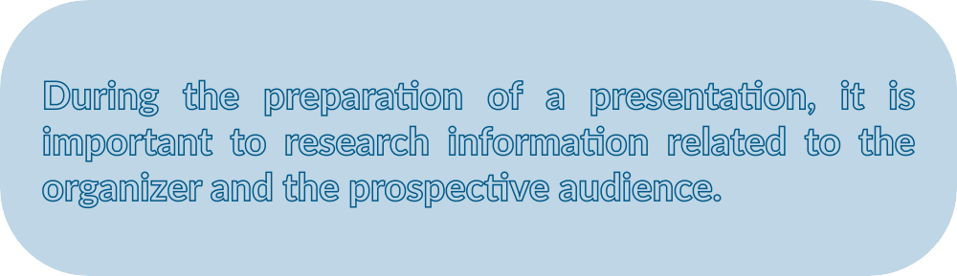

During the preparation of a presentation, it is important to research information related to the organizer and the prospective audience.

ORGANIZER
Who is the organizer? If you are attending a conference or a seminar, ﬁnd out any useful information about the organizer. Explore the organizer’s key activities and results in order to understand your role in the organized event and also use it during the preparation phase in order to ﬁnd alignment.

REASON
Try to ﬁnd out what the organizer wishes to achieve with your presentation, what their expectations are, whether the participants come voluntarily or if it is compulsory for them to attend the presentation. If the latter is the case, they may be reluctant to attend the presentation especially if this is scheduled after their shift so they may be not be thrilled about it. In this case you should examine their aﬃnities more thoroughly in order to reduce the level of their dissatisfaction.

 6




-
•
\
• -r • \o
•
a
0
0 Or: io 0

I"--,.(
\

r .,)
0 ,,,,,.- 0
f ( /\

Designing and creating

a presentation

In order to select the content, ask and answer these questions:
- What is the main point I want to get across?
- Is there something speciﬁc I want my listeners to believe in or be persuaded about?
- What do my listeners know about the topic?
- What do they need or want to know?



In order to plan the content ask and answer these questions
- How much new information can be absorbed?
- What kind of information will best support my main point?
- Which argument(s) will appeal to my listeners? [Be selective because listeners are able to remember 3 or 4 arguments max.]











How is the introduction going to be?
2.2 Structure:
How to form the structure:
Introduction – Body - Conclusion
Then you may use one of the following techniques:
  - Provide an outline of the content
  - Explain the relevance
  - Describe the outline of the presentation or present the beneﬁts or narrate a relevant story to capture the attention
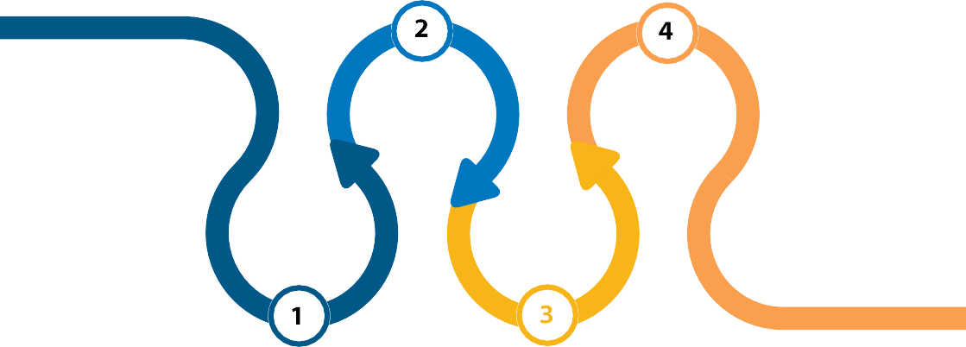
  - Narrate a relevant story to capture the attention

How am I going to structure the body?
Present the main question/ topic.
Explain the signiﬁcance: Why is it important to be answered?
Present results and support them with: facts/ evidence in to establish credibility (cite references/ publications). [listeners can remember 3 - 4 arguments]
Present important implications

How am I going to structure the conclusion?
Signal the end
Repeat the main question and summarize
Complete with 2-3 sentences which are meaningful, accurate and echo in minds by selecting one of the techniques below:
Use an inspirational quote or famous wise words: “I am reminded of what X…said….”
Invite people for action:
“Now let’s apply this on ….!”
Single out a key message:
“If you take one thing of this talk, this….”











A message is remembered if it is repeated in diﬀerent forms so is it good to support the presentation with visuals. However, if this is not possible remember that the human factor renders a presentation memorable.
2.3 Adding visuals to the
presentation








People who know what they are talking about don’t need Power Point

Slides
Steve Jobs

- Keep slide simple; each slide should be understood within 7 seconds
- Use short clear titles
- Present one idea per slide
- Do not insert full text; the text should be short
- Use rule of 6, that is 6 lines per slide, 6 words per line
- The font should be simple and legible
- Font size should be 24-28
- Font should be consistent
- Avoid capitals; low case letters are easier read
- Avoid underlining
- Check spelling
- Choose colours carefully; avoid using more than three colours

Graphs – Charts- Pictures- Tables
  - Select easy-to-read and understand graphs; the audience should understand it just by looking at it
  - Draw the attention to the key piece of information ; explain why it is important












Practising the presentation


Presentation rehearsal
Rehearsing a presentation is important for assuring self-conﬁdence and persuasiveness. The more you rehearse the presentation, the less likely it is that stage fright and possible unforeseen circumstances will hinder you in achieving the objective of the presentation.
It is useful to rehearse the performance of the presentation by doing it out loud. The written material we read typically takes less time than an actual presentation delivery. It is ideal to rehearse the presentation in the same or a similar room and to control the time. It is advisable to record yourself during practice because we may be surprised by the way certain words are pronounced or by the paraverbal communication in general, the length of the delivery or the non-verbal message we send. Today, mobile phones enable recording, which without additional technical resources can help us see and hear ourselves before we go out in front of an audience.



,,,,,, ,,,,,, I

Performance






Performance
The average presentation speed is 100 words per minute. Use short sentences to allow the listener to understand and follow you.
There are several elements that, in addition to expert knowledge, are crucial for creating a good impression of the presentation and the presenter:
- Persuasiveness - if we are honest and persuasive, the audience will see us as authentic
- Enthusiasm - if you like the topic you are talking about, your passion will be contagious and it will spark interest among the audience
- Spontaneity and being casual - excessive formality may leave an impression of insecurity, while spontaneity and casual style communicate the impression of competence and self-conﬁdence. If appropriate, use humour. If the topic is serious, measured and appropriate humour can draw the audience’s attention
- Power of expression - speak conﬁdently, clearly and loudly


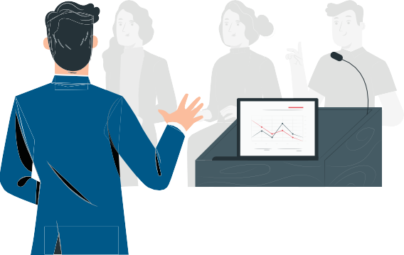

Verbal Delivery
  - Start your presentation without looking at your notes
  - Use simple sentences, clear examples
  - Use active verbs avoid technical terms unless known by the audience
  - Speak a little louder than you think is necessary
  - The larger the audience, the more slowly you should speak
  - Vary the speed; speak more slowly in the introduction and in the conclusion
  - Make small pauses (1-2’’) during the performance
  - Start and end with direct eye contact;
  - Look at the participants’ face [looking at a person keeps them engaged]
  - Look on one person for 1-2 seconds and then move on to the next

Handling Nervousness
  - Be well prepared, this attributes conﬁdence
  - Rehearse your presentation and time yourself
  - Convert your stress into enthusiasm and energy
  - Have small talk with the audience before the presentation
  - Avoid standing in one spot and move purposefully in the room
  - Establish rapport with audience through eye contact; This contributes to your relaxation
  - Ten minutes before the presentation yawn; It helps relaxation of face and throat muscles

Body Language
•Stand straight but not stiﬀ; this assists better breathing and voice production
•Balance your weight evenly on both feet. Do not sway
•Use gestures to mark transition from one part to another
•Keep hands away from face
•Smile!


Appendices

Tips on content preparation

Things to
DO while preparing content

Think of the audience needs: How is my topic relevant or useful for them?
Consider their age, education, gender, economic status. Depending on these factors, the same topic may be presented in diﬀerent ways.
Link your topic to the audience needs: Try to connect the focus of your topic with subjects that appeal to most people such as:
- Health impact
- Eﬃciency
- Low cost
- Competitiveness in cost and performance
- Products of good and even quality
- Elimination of wasted time, energy or money
- Freedom from pollution



Things to DO while preparing content

Organize the information of the presentation in a clear manner. Ways of organizing information include:
- Chronological sequence
- Most important to least important
- General to particular
- One point of view compared to another



Things to
DO while preparing content

You may use a technique to structure an interesting opening that gives them a reason to listen; Select one from the list:
- Provide your audience with a problem to think about
Imagine … How would you … Have you ever wondered ….?
How many of you would ….? Think about … Do you think it is possible?

- Make it interesting for your audience by oﬀering some surprising data
Did you know …?
According to the latest research, … The data show that …
A few days ago I read that …




































- Share a real-life story or an anecdote

As you know … It reminds me of … Have you ever been in a situation …? When this happened to me …


Things to
DO while preparing content

If more than one presenter is invited, ﬁnd out what their topics are in order to avoid repeating what someone has mentioned.

Time allotted to the presentation is crucial for determining the framework and the scope of the presentation. Check how much time has been allotted to your presentation and prepare your delivery accordingly. No one likes presenters who do not respect the schedule.

Size of audience and the venue may have an impact on the presentation. Smaller spaces allow for establishing a more direct contact with the audience. Large spaces are more formal, less personal and are not suitable for workshops. What is the layout of the space? Can you intervene in the space and arrange the layout as you see it ﬁt before your presentation?

Edit your content

Things to AVOID while preparing the content

Present a topic without adequate preparation; This can make your presentation sound vague or pointless. Therefore extensive planning of the presentation is required in order to enable you to know your topic well and be enthusiastic about it.

If a powerpoint is used, do not employ it as if it is the key element of the presentation that guides you. A Powerpoint acts as attention grabber; It is YOU who presents, not the powerpoint.

Avoid mentioning too many details and arguments as this can create confusion.





Tips on delivery

Things to DO before and
while delivering the presentation

How to handle with stress before the presentation
Prepare well and in advance; this gives you conﬁdence. Rehearse and time yourself. Allow a little time over when you practice as it will take you longer on the day.
Think of possible questions that may be posed by the audience.
Try to familiarize yourself with the venue and the equipment as this protects you from last minute problems (like failing to upload your PowerPoint etc) which cause a lot of stress.
Due to stress, face muscles stress and this can aﬀect how you look and sound. You may overcome this by yawning; if possible ten minutes before the presentation yawn repeatedly in private as this relaxes faces muscles and facilitates voice projection.

How to establish contact with the audience before your presentation


Have small talk with one or two or more from the audience before your presentation. This is not always possible with a large audience, yet you may speak with the person sitting next to you.

Things to
DO while delivering
Always remember that the key for eﬀective presentations is YOU. It is not the slides or the venue. Therefore, make the audience understand your points, follow your rationale and feel your enthusiasm for the topic. If you are interested in it, they will be interested too.
Thank the organizer.
Clearly set the objective and the intended outcome(s) of the presentation.
State preference for questions: are they going to be asked during or after the presentation?
Stand where you can see everyone and do not block the screen, if any.
Although the audience is a group of people, view them as a group of individuals and address them as if they were a single person.
Avoid reading from your manuscript all the time; face the audience occasionally.
Do not read the slides, it is very boring.
Rephrase their content or explain them. Slides are attention getters not the key medium of your presentation.

Move occasionally, for instance to mark transition between sections; this enables you to feel less tense. Avoid swaying.
Use hand gestures to emphasize a point, yet this should be natural.
Keep hands away from face.
When pointing to the screen, do not wave and face the audience to speak.
The larger the venue the slower you should speak. If nervous, you may speak very quickly. Consider drinking some water to slow down.
Vary the volume to catch the audience attention and vary the pace. Make occasional small pauses for 1-2 seconds, especially to mark the key points. Small pauses can re-ignite the attention of the audience. Before the conclusion, make a pause.
Smile! It gives a positive impression
When you solicit questions try to be more open in your way of doing so. It is better to ask ‘Who would like more details?” than “Any questions?”.
If you wish to prompt questions you may say: “A question that may arise is …..” or “A question that often comes up is …”

Things to AVOID while delivering the presentation

Reading the slides, reading from a manuscript

Speaking to the screen, to the walls, to anything but the audience

Mumbling or speaking too quietly, or too fast

Using abbreviations or jargon or inappropriate language

Exceeding the time allotted to as you ‘ll have to rush in the end and ignore parts of your presentation

Speaking monotonously; you sound ﬂat with lack of interest so you 'll loose the audience's interest. Give weight to your words

Raizing your voice even if someone has been rather aggressive

References
Communication Skills. Delivering a Presentation.
PPT prepared by Tatjana Badrov and Ivana Jurković
Making and Delivering a Presentation. PPT prepared by Tatjana Badrov and Ivana Jurković
Presentation Skills and Techniques. PPT prepared by Vassilia Kazamia
Dolan, R. 2017. Eﬀective Presentation Skills. FEMS Microbiology Letters, pp 1-3.
Olsen, L. and T. N. Huckin. 1991.Technical Writing and Professional Communication. Second Edition. New York: McGraw-Hill
Powell, M. 2011. Dynamic Presentations.
Cambridge: Cambridge University Press
Reekers, J. A. 2010. Presenting at Medical Meetings. Heidelberg: Springer
Karten, N., 2010, Presentation skills for technical professionals, IT Governance Publishing, Cambridgeshire
Badrov, T. 2020, Communication skills in engineering, Bjelovar University of Applied Sciences

 32


This project has been funded with support from the European Commission.
This communication reﬂects the views only of the authors, and the Commission cannot be held responsible for any use which may be made of the information contained therein.

